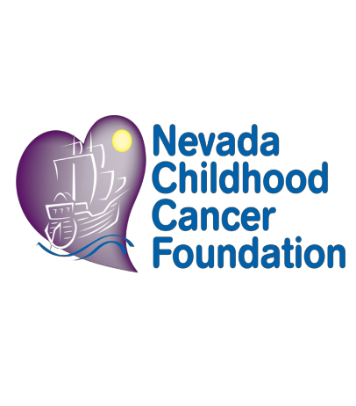
Dear Adopt-a-Family Participant,

First, let me start by saying Thank you! The team at the Nevada Childhood Cancer Foundation (NVCCF) works year-round to assist families whose children are stricken with life threatening illnesses and help them prepare and cope with the changes that ensue. Your participation in this program is not only welcomed and appreciated, but I can guarantee it will make all the difference in the world to those we serve in the community.

Each year NVCCF adopts out over forty families in the community who have been financially devastated by their child’s illness and the medical costs that come with it. This becomes especially difficult during the Holiday Season. This year you have the chance to make an incredible, positive difference in the life of a child and their family.

Enclosed is a detailed description of our Holiday Adopt-a-Family Program. Please read it carefully as it contains pertinent information regarding client confidentiality, Adopter anonymity, what to expect from your family, what to expect from NVCCF, dates and deadlines, and delivery information & instruction.

As with any growing program, change is often the inevitable. There are several notable changes to our program this year. So even if you’ve participated in years past, please take time to review this in detail. If after you’ve reviewed the attached information and would like to participate in our program, please complete and sign and date the last page of this packet and mail, e-mail, or fax back to me no later than Friday, November 4, 2022. Requests for families and packets received after this date will not be accepted. Families recommended for this program are carefully assessed by our licensed Social Workers to ensure they meet the eligibility criteria for this program as outlined by NVCCF President/CEO, Mr. Jeff Gordon. Therefore, it is imperative that I receive your completed agreement by the date listed above.

If you have any questions and/or concerns, please feel free to contact me at the number listed below. We hope to bring many smiles to the faces of those who need it the most during this holiday season and with your time, generosity, and collaboration I know we can make this holiday season one to remember! ☺

Warm Wishes,
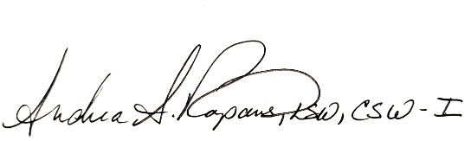

Andrea Rapanos, MSW, LSW, CSW-I
Director of Patient Programs & Services
Nevada Childhood Cancer Foundation
702-735-8434 – Office
702-735-8431 – Fax
andrea@nvccf.org

☞ How are families-in-need identified & enrolled in this program?

Families are referred in several ways: social work referral, local physician(s), medical staff, self- referral, friends, and family. Families are adopted out on a first come, first serve basis after being carefully screened by our licensed Social Worker’s to determine a need for assistance through the Holiday Adopt-a-Family Program. Once the need for assistance has been identified and the recommendation made, NVCCF will cross-reference the recommendation against similar programs with other agencies in the community to keep “double dipping” at a minimum. Once confirmed, a NVCCF staff member will notify the family by phone that they have been selected to participate in this program and we will mail them their Holiday Adopt-a-Family Packet.

☞ How many families can I (we) adopt?

You may adopt as many families as you can afford to. Past participants have adopted a single family and others have adopted up to 10 families. The number of families you choose to adopt is completely up to you. NVCCF asks that you be as specific as possible. If you want one (1) family with no more than five (5) members in that family, then that is what you need to tell us. If you’d like seven families and could care less about how many members per family, then you’ll need to specify that as well.

☞ In this program, how is “family” defined?

In this program, a “family” consists of the ailed child, their parent(s) or legal guardian, immediate
siblings who reside in the home, and, on occasion, their family pet. ☺

☞ Are there exceptions?

Yes. There are times when an older sibling, aunt, uncle, or grandparent assume the role of the absent parent and become the caregiver. In those instances, and only in those instances, is someone other than an immediate family member allowed to participate.

☞ What can we expect to receive from the family(ies) I (we) adopt?

You will receive a written biography of the diagnosed child and their family. Biographies tend to include a lot of detailed, personal information surrounding the circumstances of the child’s diagnosis, their treatment, and how it’s affected the family both emotionally, financially, and spiritually. When reading the biography please remember that what these families experience as a result of the child’s diagnosis can evoke some strong and passionate feelings that will sometimes come out on paper and give you a deeper glimpse into the intimate details of their lives. It is because of this that NVCCF requires ALL Participants to demonstrate and maintain confidentiality of any and ALL information shared between you and the family you adopt.

YOU MAY OR MAY NOT RECEIVE A CHILD DIAGNOSED WITH CANCER. While
we are The Nevada Childhood Cancer Foundation, our mission statement affords our agency to see and work with children who are diagnosed with a broad range of chronic and critical illnesses.

You will also receive a “Wish List” from each member of the family you adopt. This list will give you an idea of their needs and their wants. NVCCF asks that you attempt to meet the needs before meeting the wants. We ask our families to be as detailed as possible when writing their

“Wish List” by including name, age, favorite color, clothing size, shoe size, coat size, bed size, and
even providing a copy of a bill that they need help with.

☞ What items can I expect to see on their Wish List?

We have asked our families to list their individual needs, family needs, and household needs. Needs may consist of groceries, gas cards, help with a utility or mortgage bill, clothing, shoes, coats, toiletries, bedding, beds, dishes, bath towels, household cleaners, prescription costs, eye glasses, bus pass/tokens, furniture, vehicle maintenance/repair, work boots, Christmas Dinner and sometimes even a Christmas Tree. Wants, or their “Wishes”, may consist of a new bike, music CD, iPod, skateboard, gift cards to their favorite department stores, mall, or restaurant, a new video game/system, books, board games, favorite sports team gear, tickets to a show or the
movies, crayons/markers, T.V.’s and/or Stereo System, new perfume/cologne, fancy purse, hi- tech power tool, a vacation, a computer, or new puppy/cat/hamster/fish. You are not expected to fulfill every item on their list. Our families are informed of this as well. All we ask is that you do what you can do.

☞ Can I (we) collect cash for our family(ies)?

Yes, you may. You cannot gift cash to the family directly, it should be sent to Nevada Childhood Cancer Foundation for management. Some families can have a severe financial consequence that will impede benefits in place critical to the child’s continuation of care. All donations will be restricted to the family designated. Family funds must be used by the end of the following calendar year and families are made aware of this. If necessary, the foundation reserves the right to utilize excessive donations toward emergency assistance for other qualified participating families.

Checks for cash donations to the family should be made out to NVCCF with the Child’s name and Family Fund (i.e., “Johnny Doe Family Fund”) in the memo line.

☞ How are gifts delivered to the family?

If you opt to remain Anonymous and not participate in the delivery, you will need to bring the gifts you’ve purchased, wrapped and properly addressed to the individual whom the gift was purchased for, to NVCCF offices on Monday, December 12th, 2022. An NVCCF staff member will have the family come and pick-up their gifts. If you would like to make the delivery yourself, you will need to contact the adoptee directly, and set up a time and date for delivery and then let an NVCCF staffer know of that date and time for our records. All gifts should be wrapped and addressed to the proper individual for whom the gift was purchased for.

All gifts will need to be delivered the week of December 12th , 2022 through December 17th, 2022.

☞ What should I do if I have a question or concern regarding the Wish List?

If there are any questions and/or concerns regarding the list and any item on it, please contact Andrea Rapanos or Nicki Klein-Richter at 702-735-8434 or at andrea@nvccf.org or nicki@nvccf.org for further discussion and/or assistance. Please refrain from giving the family your personal contact information.

☞ Understanding of the sick & things to keep in mind…

When a child is diagnosed with a chronic or terminal illness they often experience significant physical changes that can really take its toll on their self-esteem. Treatment can cause hair loss, splotchy/flaky skin, mouth sores, weight loss/gain, fatigue, moodiness, etc… Our clients, particularly our teens, become very self-conscious and will not want someone to purchase personal items such as toiletries or clothing for them. Instead, they will often request a gift card so that they have the ability to get those personal items themselves. Some donors like to take pictures with the family when they deliver gifts to the home. While most families are happy to take a picture with you, some clients will not want to participate because of the way they look. These changes, amongst everything else that comes with their diagnosis, are very difficult for them to deal with and we ask that you respect their wishes with regards to their personal preferences. We’d also like to remind you that you may not always receive a written “Thank You” note/card from the family. Everyone has different ideas of what proper ‘Thank You’ etiquette is or should be. Sometimes a proper “Thank You” will come in the form of a hug, a handshake, tears, or simply saying “Thank You” just before you leave their home.

☞ Dates & Deadlines

Adopt-a-Family Program Opens: September 19, 2022

Last Day to request a Family: November 4, 2022

Deliveries to be completed the week of: December 12th – December 17th, 2022
Anonymous Donors Need to have their family’s gifts to NVCCF on Monday, December 12 1212th 12th
by 3:00pm.

**Any requests to adopt a family after the November 4th deadline will not be accepted. Instead, you will be invited to contribute to the NVCCF Gift Card Program that will be utilized by ALL clients and families of NVCCF.**

☞ Understanding HIPAA and how it applies to this program

Because NVCCF is considered a “covered entity” under the Health Insurance Portability and Accountability Act of 1996 (HIPAA), we are subject the rules and regulations as outlined by this piece of legislation. The HIPAA Privacy Standards regulate the use and disclosure of individually identifiable health information. This includes ANY and ALL information you receive on the family you’ve adopted. The “Minimum Necessary Rule” is one of the most important and most difficult rules in the Privacy Standards. This rule states that you must make all reasonable efforts not to use or disclose more than the minimum amount of protected health information (PHI) necessary to accomplish the intended purpose of the permitted use or disclosure. This means that any patient/family identifiable information must NOT be used. If you are resourcing or

fundraising for your family, discretion is mandatory and non-negotiable. The following is a brief example of what is acceptable:

Dear So & So,

My name is John and I work for HIPAA Inc. We have partnered with the Nevada Childhood Cancer Foundation this holiday season and have adopted a family for the holidays. Our family consists of a single mom and her three children, ages 2, 3, and 4. One of her children has been diagnosed with Leukemia and is currently undergoing several rounds of chemotherapy. This has had a significant negative financial impact on this family, and we are asking for your help….

If you have any questions and/or concerns about what is appropriate or allowed, please contact NVCCF at 702-735-8434 to clarify. Please remember to keep the information as discreet as possible. IT IS THE LAW.

In order to receive a TAX DONATION LETTER:
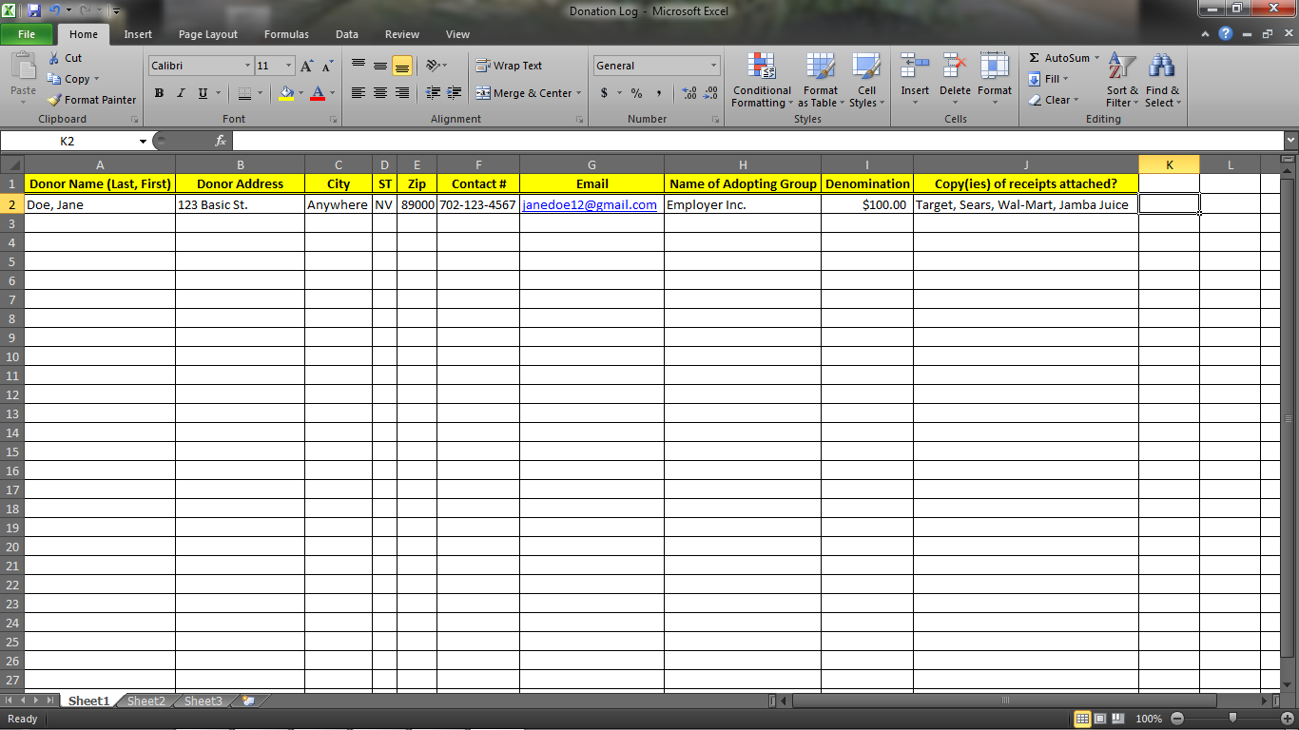
A tax donation letter can be given to those who participate in adopting a family by keeping the above record and submitting it to Anna Laufenburger, Executive Administrator NO LATER THAN DECEMBER 31ST , 2022. If you have questions or concerns about what is needed for a tax donation letter, Anna can be reached via email at anna@nvccf.org or by phone at 702-735-8434.

A DONOR(S) CANNOT AND WILL NOT RECEIVE A TAX DONATION LETTER FOR ANY
CASH GIVEN DIRECTLY TO THE FAMILY(IES) YOU’VE ADOPTED. YOU MUST PROVIDE
RECEIPTS FOR ALL DONATIONS MADE THAT YOU HAVE CALCULATED INTO THE
DENOMINATION FOR YOUR TAX LETTER.

It is the mission of the Nevada Childhood Cancer Foundation to ensure the privacy and protection of all its clients in accordance with the Health Insurance Portability and Accountability Act of 1996 (HIPAA). As such, participants in the Holiday Adopt-a-Family Program are also expected to protect and keep private any and all information shared with them regarding the clients we serve. If you have read, understand, and agree to the information contained in this packet please fill out the information below and return it to:

Nevada Childhood Cancer Foundation
Attn: Andrea Rapanos, Director of Patient Programs & Services
3711 Sunset Rd.
Las Vegas, NV 89120

Example of a Wish List

Mom (Age 36) Needs:
- Blouses for work (size M, 8/10 – Any color)
- dress slacks (size 10 – Any color)
- Jeans (Straight leg or Skinny, size 10)
- New Pajamas (size M, 8/10)
- Dress socks for work
- Cotton socks for play
- Panties (size M)
- New Brazier (Bra, size 34/C – Any color, fabric)
- New Sports Bra
- help with groceries
- Help with our power bill
- Co-pay assistance for my son
- new dish towels
- New mixing bowls
- a colander
- help with covering the cost of my prescription eye wear
- Pine-Sol cleaner & bleach
- Laundry detergent (no fragrance due to skin allergies)
- An oil change for my car
- New front tires
- New curling iron (1” barrel)
- A Christmas Tree (Artificial)
- A couch (we don’t have one and use lawn chairs to sit on)
- A winter coat (size M – Any color)
- Sneakers (size 7 ½ womens – Any color)
- New sheets for my bed (size Queen)
- New shower curtain (Brown or Tan in color)
- Toiletries (toothbrush, toothpaste (we use Colgate), Shampoo & Rinse, Body Wash (We use Herbal Essence, but are open to new brands)

Wants:
- White Diamonds perfume by Elizabeth Taylor
- A gift card to Sephora for new make-up
- A manicure and pedicure
- New fashion jewelry
- New seat covers for my car (I drive a 2010 Toyota Corolla)
- A nice dinner out with my husband at Tony Roma’s (it was our favorite place to dine)

Dad (Age 40) Needs:
- New steel toe work boots (Size 10 ½)
- Boot socks
- Rental assistance
- Help covering our son’s co-pay’s
- Help with our Rent (Please see the attached lease agreement)
- Groceries (Gift card to Albertsons and/or Wal-Mart)
- A new lawn mower
- A new power drill and drill bit set
- Oil change and maintenance check for my truck
- A dinner coat so I don’t have to wear my work one out (Size L)
- Gloves (size L)
- New Boxer Briefs (size L – Any color)
- New undershirts (size L – White only, crew neck)
- New silverware and measuring cups
Wants:
- A Dallas Cowboys Hoodie (Size L)
- A new leather belt (one black, one brown, size 38)
- Eternity for men by Calvin Klein (cologne)
- New power tools
- A new electric shaver
- Tickets to a show (Any show on the Las Vegas Strip)
- iTunes gift card
- A man’s recliner for watching football ☺
- A Dallas Cowboys phone cover for my Blackberry
- A night out with my Wife (without the kids)
- A new trifold leather wallet
- A new laptop (ours is very old and doesn’t always work)
- New slippers (size 10 ½ )
Child – Male (Age 8) Needs:
- Pants (both dress & jeans, size 7 slim – Any color)
- Collared shirts (Long sleeve, size M any color)
- Socks (size 6, ankle and crew)
- Play shirts (any color or graphic, size M)
- Underwear (size M)
- New pajamas (He likes football, solid colors, or Pokemon, size M or 7)
- New slippers (size 6)
- New sneakers (Nike, size 6)
- Bigger coat (mine is too small, size M)

- New Backpack for school
- New glasses (my frames broke)
Wants:
- A Dallas Cowboys hoodie or jersey (size M)
- A Dallas Cowboys football
- A new bike
- Gift card for McDonald’s
- A Tony Hawk skateboard (or similar one)
- Helmet and pads
- New X-box and games
- Radio for my room
- Gift card for Game Stop
Child – Female (Age 14) Needs:
- Tops, button up or not (Junior size S, favorite colors are black, green, bright pink, and lime green)
- Skinny jeans (Size 5)
- Socks (crew and ankle, size 5)
- Pajamas (Size S in Juniors)
- New book bag (my strap broke)
- New Nike shoes (white or hot pink in color, size 5)
- New toothbrush
- New sheets for my bed (size twin – black or green in color if possible)
- A graphing calculator
- A new bed
Wants:
- iPad
- Nail polish (All bright colors)
- Gift card for PacSun
- Gift card for Starbucks
- Girls Dallas Cowboys Jersey
- New boots with a heel (black or brown)
- A mani/pedi
- A hair cut and color
- Movie passes
- Fashion scarfs
- Gift card for the mall
- iTunes gift card
- Tickets to see Justin Bieber

